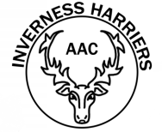
CLUB VEST ORDER FORM
Athlete Name
Age Group

CHILD - £12.50 ADULT - £14.00
Female Female
SIZE | QTY |  | SIZE | QTY
Small (28) |  |  | Small
Medium (30) |  |  | Medium
Large (32) |  |  | Large
 |  |  | XL
 |  |  | XXL

Male Male
SIZE | QTY |  | SIZE | QTY
Small (28) |  |  | Small
Medium (30) |  |  | Medium
Large (32) |  |  | Large
 |  |  | XL
 |  |  | XXL

Total Amount Due (£)

Notes:
All cheques should be made payable to “Inverness Harriers AAC”.
Return this completed form with payment to your coach.
Forms will not be accepted without the appropriate payment.

