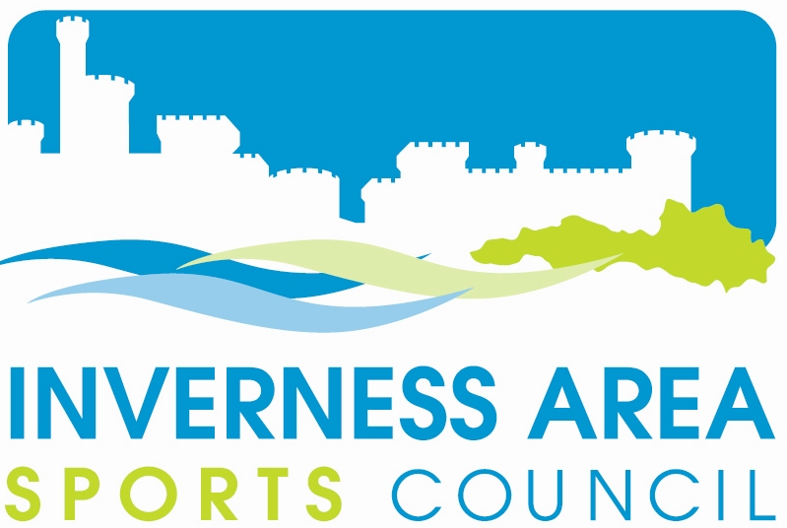
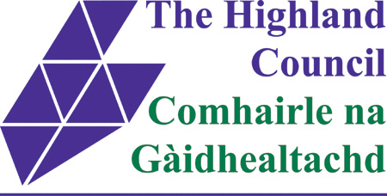
Inverness Area Sports Council
Application for Grant Aid

Gheibh sibh Spòrs à Spòrs!

Club/Applicant Details
Name of Club: …………………………………………………………………………………………………………..

Secretary’s Name: ……………………………………………………………...…Telephone: …………………….

Secretary’s Address: ………………………………………………………………Postcode: ………………………

E-mail Address: …………………………………………………………………………………………………………
If application is on behalf of a club member (eg for an Excellence Grant), please provide their details also:
Name: ……………………………………………………………………………………………………………….
Address: ……………………………………………………………………………………………………………….
Postcode:………………………………………………Tel No: …………………………………………………….
E-mail address: ………………………………………………………………………………………………………..
Project Details
Please describe what the grant will be used for:  ..………………………………………………………………….…  …………………………………………………………………………………………………………………………………………………………………………………………………..………………….  ..………………………………………………………………….…  ………………………………………………………………………  Please give as much information as possible i.e. type of equipment, Coaching Course etc. Please attach additional sheet if required.  Please detail the application costs.  Travel Miles: .……….…..miles x 25p = £……...….…  Accommodation: ………nights x £35 = £……………  Subsistence: ………….…days x £10 = £……………  Course/Event Fees: £………………  Equipment: £………………  Other (Please detail): ……………………………..……………………£……….…  ……………………………..……………………£……….…  ………………………………..…………………£……….…  ………………………………..…………………£……….…  TOTAL COST: £……………… | Which category of grant are you applying for (please tick one only):  Start Up Grants  Coaching Grants  Equipment Grants  Achieving Excellence Grants  Sports Development/Events Grants  Discretionary Grants  Total Cost of Project: £…………………  (Please detail in opposite section. Note: The amount awarded will be a percentage of total cost of project, not of grant requested).  Grant Requested: £…………………  Club’s Contribution: £…………………  Other Funding Sources: £ …………………  Detail of Other Sources: ……...……………  …………………………………………………  Total combined funding received this year from other Sports Councils in the Highland Area:  £  Does the Club have:  Public Liability Insurance Yes No Equipment Insurance Yes No
Declaration
I declare that I have read and understood the guidelines (see overleaf) and that the information supplied above is correct & complete and does not constitute a retrospective application. I further declare that I have enclosed the following information, if not previously done so: (please tick all that apply or are relevant)
A formal letter of invitation to the Regional or National/International Squad
Constitution Latest Accounts Latest Bank Statement 2 Estimates (if for equipment)

Signed …………………………………………Position …………………………………… Date:…………………

PLEASE RETURN TO: IASC, Suite 484, 8 Church Street, Inverness, IV1 1EA.
Summary grant guidelines are detailed below - for a full copy of the Highland Council guidelines please e-mail treasurer@sportinverness.co.uk

START UP GRANTS
- To encourage greater participation in sport at grassroots level.
- Maximum level of funding – 50% up to £200
- Available to new groups to apply for once they have completed and returned their affiliation form and fee.
- Groups should provide a detailed outline of their aims and objectives and full financial information on how they would propose to use the grant.
- We may seek re-imbursement of a start up grant if a group fails to maintain its membership of the sports council.

COACHING GRANTS
- To encourage the development of more qualified coaches. For example, a national governing body coaching or referee’s certificate; a Scottish Qualifications Authority (SQA) award, Sports Coach UK or other appropriate qualification.
- Maximum level of funding – £250 per individual per course
- Maximum award 50% of eligible costs which include travel, course fees and accommodation expenses.
- Usually, applications must be made by, and grants paid to, the affiliated club rather than an individual.
- Recipients should be prepared to assist with local events or coaching courses to the general benefit of sport in the area.

SPORTS EQUIPMENT GRANTS
- To provide equipment to increase participation and access to sporting opportunities.
- Maximum level of support from Highland Council funds - £500
- Maximum award 50% eligible costs.
- For equipment which becomes the property of the affiliated club.
- Clubs will be asked to insure the items of equipment purchased.
- Grants are not available for personal items such as team clothing; tracksuits, strips etc.
- If a club ceases to exist within three years of receiving an equipment grant, then the equipment or a proportion of the sale value of the equipment should revert to the sports council.

ACHIEVING EXCELLENCE GRANTS
- To support individuals living in Highland who can provide appropriate evidence that they have been invited by a competitive and recognised selection process to join Regional or National/International squads.
- A formal letter of invitation to the squad / team must be submitted with the grant application form.
- Usually, applications must be made by, and grants paid to, the affiliated club rather than an individual.
- Maximum award 50% of eligible costs incurred in attending training or sessions or competing in events.
- Maximum level of funding to benefit one individual in one financial year
- Regional Squad (i.e. Highland or North District) £250
- National Squad (i.e. Scottish)/International Squad (i.e. GB or European) £500
- Final award will take account of other sources of funding that may be available such as Coaching Highland, Sports Lottery programmes, schemes run by governing bodies, representational grants for school pupils etc.

SPORT DEVELOPMENT / EVENTS GRANTS
- To support clubs who want to develop their club and increase participation in sport by improving their infrastructure, junior sections, office bearer skills training, organising events etc.
- Maximum level of funding – £500
- Maximum level of grant 50% of eligible costs

DISCRETIONARY GRANTS
- Maximum level of funding - £500
- Maximum level of grant 50% of eligible costs
- Normally only available to affiliated sports council members but exceptionally available for a non-member.

GENERAL CONDITIONS
- Limits: Travel 25p per mile; Subsistence £10 per day; Accommodation £35 per night.
- No retrospective applications will be accepted.
- Maximum total grants available to any club in any financial year - £1000 (subject to change).
- Closing date: applications must be received by Friday 12 noon prior to each Sports Council Meeting.
- Clubs must attend the next sports council meeting in case of any queries – if not present, grant will be deferred – after 3 deferrals grant will be deemed void and cancelled.

Note: Meetings held 7pm on last Tuesday in January, March, May, July, September and November.

